
Hardware Review I Memo
To: Dr. David Willy
From: NASA RASC-AL
Date: 09/17/2021
Subject: Hardware Review 1

This memo details the current state of the physical system, the changes in design and analysis conducted since the beginning of the semester. The memo will also detail the justification for the for material chosen, and reasoning behind the structure as well as the schedule of the project.
- Introduction
In response to the Revolutionary Aerospace Systems Concepts – Academic Linkage (RASC-AL), the team elected to pursue NASA’s objective to establish a lunar presence by the end of 2028. The main requirements of the project entail a low-mass habitat that can support a crew of 2 for 30 days, occupy the habitat should be ready for use by 2028, a maximum weight of 6000kg, and no more than $1 billion per year from 2022 to 2028.
At the end of the last semester, the subsystems for the structure, pressure wall and the Whipple shield were decided on and a CAD model was built. The following image illustrates the previous CAD model.
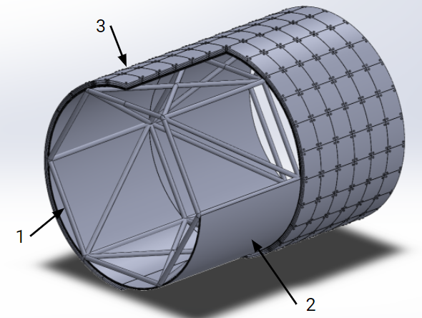
Figure 1: Full Scale CAD Model

- Analytical Progress
- Bone Structure Improvements
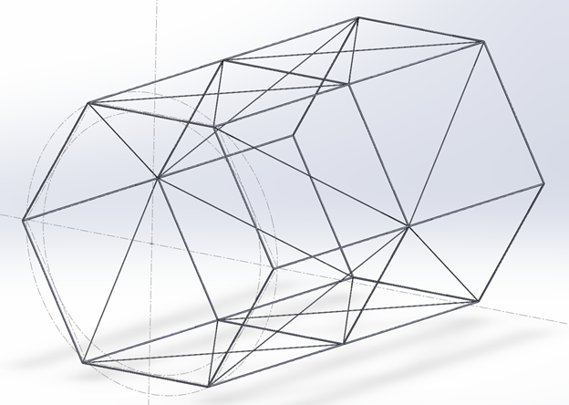
Figure 2: End of Spring 2021 semester CAD model of the Bone Structure
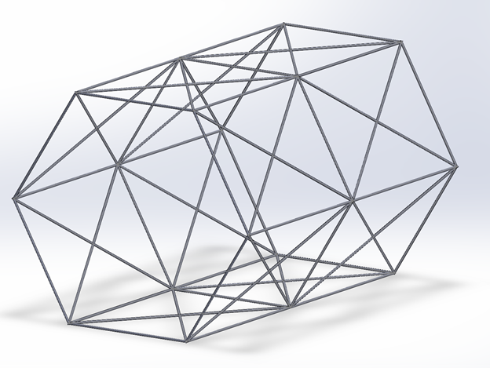
Figure 3: Updated Weldment CAD model of Bone Structure
Created using weldments in SOLIDWORKS using circular tubing. The previously used assembly had failed to mesh properly during structural analysis performed in ANSYS and SOLIDWORKS, thus it was necessary to create a bone structure as a single part with improved meshing for structural analysis. The previous model had an approximate weight of 45kg and a circular tubing dimension of 21.3mm x 2.3mm (outer diameter x thickness respectively) compared to the updated model that has an approximate weight of 145kg and a circular tubing dimension of 33.7mm x 4.0mm. The material selected for the improved bone structure is 6061 T6 Aluminum Alloy.
- Structural Analysis
The structural analysis consisted of testing the bone structure and the pressure wall for the static stress testing and displacement.

    - Bone Structure Analysis
Initially, the bone structure was built based on titanium. However, a thorough analysis of the structure had to be conducted to decide on a material. One reason was time and the second was that the model had too many parts that restricted Solidworks from meshing the structure. As a result, a new model was generated from using weldments as described above which made the process easier.
One of the assumptions made was that the weld material used was assumed to have the same properties as the metal itself. Below describes the analysis done on the bone structure. As seen, the forces are facing one direction (up) only as the model still had many more parts that made it harder for Solidworks to mesh and run. The force chosen was calculated from the internal pressure of 101300 N/m2 * half the surface area the beam.
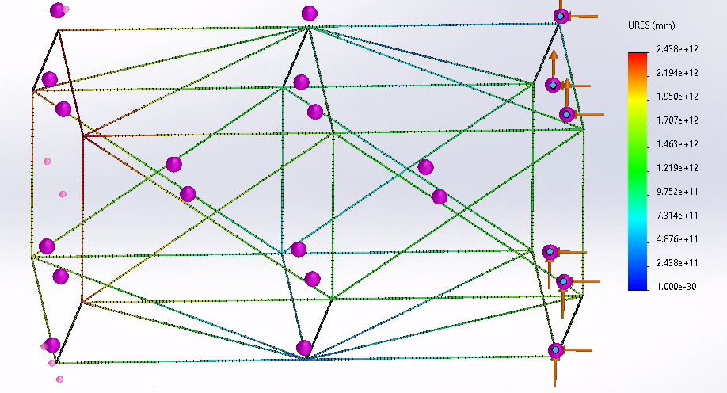
Figure 4: Bone Structure
As seen, the stress is concentrated at the opposite end of the structure. Thus, taking the stress shown in the table, the necessary diameter was calculated for the cross-section of the model resulting in the increase of the thickness of about 40%. From that, the selected diameter was ____ from the industry standards provided in Solidworks which resulted in an increase of about 73.1%. A higher diameter and thickness than the 40% were taken as the weight for the new model is still low at 74Kg.
The analysis was a back of the envelope study that allowed us to pick a better thickness for in depth analysis. The in-depth analysis could not be conducted as Solidworks still couldn’t mesh the full scale model well. Thus, the model was broken down to just the hexagonal region. The forces then were calculated as such.
$$F=101300\frac{N}{m^{2}}*226.2m^{2}*\frac{1}{3}*\frac{1}{6}=3.819 MN$$
Using the force value above, four forces were applied on each part of the beam resulting in critical stress concentrations to improve load path clarity. However, the structure handled this well and supports might be necessary for the system to work. The study was conducted for titanium and aluminum. However, at the thickness prescribed 6061 T6 Aluminum alloy was chosen. The image below illustrates the study on the hexagon.
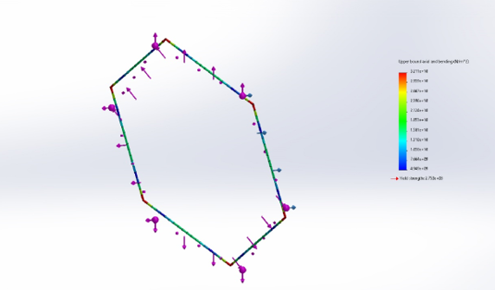
Figure 5: Hexagonal Section of Bone Structure
    - Pressure Wall Analysis
The second stress analysis was conducted on the pressure wall that rests on the inside of the bone structure. If the pressure wall is able to handle the force well enough, it would help alleviate the force acting on the bone structure. As a result, the thickness of 2.54mm and 25.4mm were compared. The 25.4mm worked better than expected.
The images from the study are illustrated below.
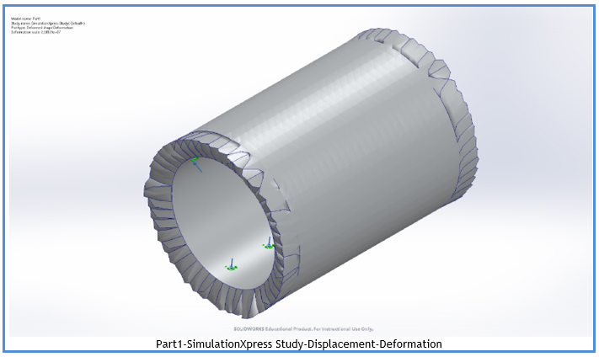
Figure 6: Displacement-Deformation results of Pressure Wall
The second study conducted compared Aluminum and Titanium. Titanium and Aluminum had similar stress and deflection parameters. However, Titanium weighed over 7000Kg. As a result, Aluminum was chosen as the ideal material for further analysis.
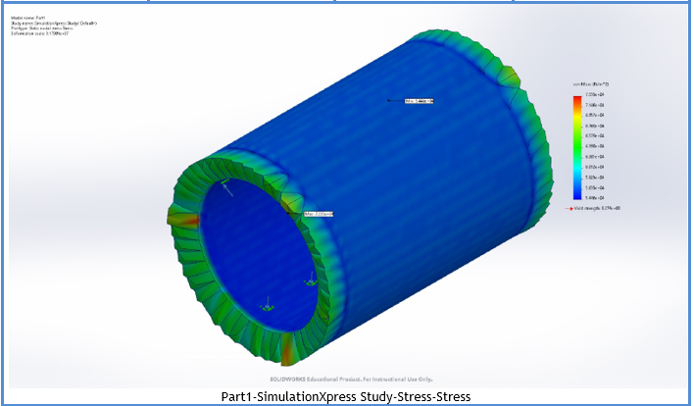
Figure 7: Stress Study results of Pressure Wall
- Whipple Shield Improvements
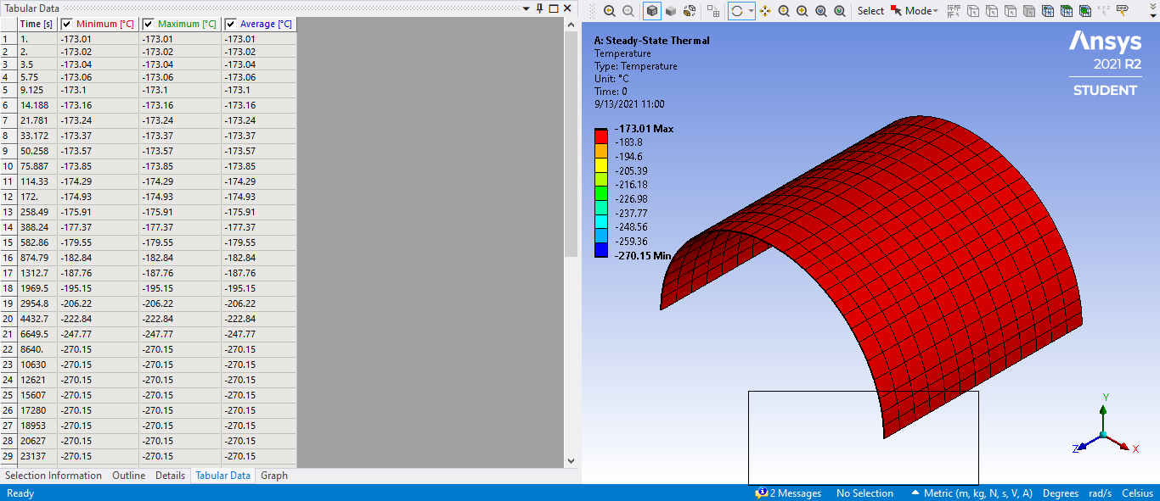
Figure 8: Intermediate Layer Thermal Analysis for Whipple Shield (Carbon Fiber)
Initially, the Whipple shield was designed to cover about 270 degrees of the entire lunar habitat. Upon further examination and discussion, it was decided that a shield that would range from 0 to 180 degrees would suffice in terms of safety. However, we still used the same materials as selected from the previous semester (i.e., carbon fiber and aluminum 6061-T6). Something that should be noted is that the design you see for the intermediate layer in figure 8 is created for the prototype. So, it is only about one-tenth the size of the actual model in all dimensions (which are 0.8128 (mm), 0.2032 (m), and 0.2032 (m) for width, length, and height respectively). To understand how the materials that were selected for the shield would withstand against the lunar surface’s environment, a thermal simulation was run through ANSYS to provide detailed information. To simulate the lunar surface’s environment within ANSYS the ambient temperature was set to the vacuum of space (and the reason for this is because the moon virtually has no atmosphere). The initial temperature was set to the highest and lowest temperatures that would be encountered on the lunar surface and was applied to the shield. A volume probe was also applied to the simulation so that we would be aware of any change in volume due to the thermal strain and stress. Previously tests were run on the aluminum rear layer which showed no significant signs of volume change or damage due to the change in temperature. In figure 8 tests were run on one of the intermediate layers which also showed no significant signs of volume change or damage due to the change in temperature. Now that we are certain that the materials, we have selected for the Whipple shield will work more focus can be applied on the nuts, bolts, and washers that will hold the shield together.
- Support System Dimensions and placeholder values
The Lunar Module will require certain Environmental Control Life Support Systems (ECLSS) to help sustain the astronauts within the capsule for the demanded amount of time. The ECLSS will consist of three different compartments. The first being the Waste Management rack which houses all the logistical waste, trash management and metabolic waste. ((1)) The Metabolic waste will consist of the fecal matter and excess urine that could not be recycled through the Water Refinery System (WRS). The waste management rack will also include the Heat Melt Compactor (HMC) technology for the processing of non-hazardous trash and will provide a 7:1 ratio reduction in trash volume ((2)). Based on the given constraints of 30 days to inhabit two astronauts, there will be about 120 kg of total trash with the average astronaut producing roughly 2 kg of trash per day. ((3)) With the assistance of the HMC, the trash can be compacted to 9” square tiles that will require approximately 5’x5’ of space for the trash tiles and the HMC

.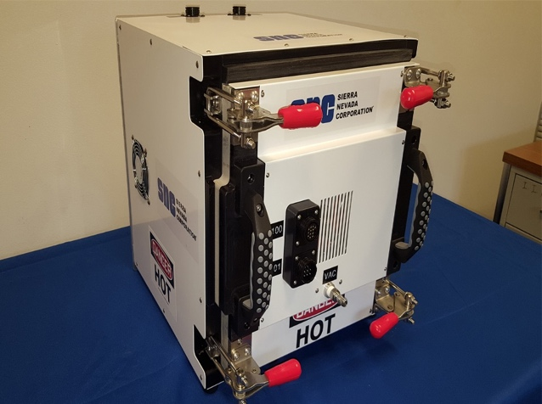 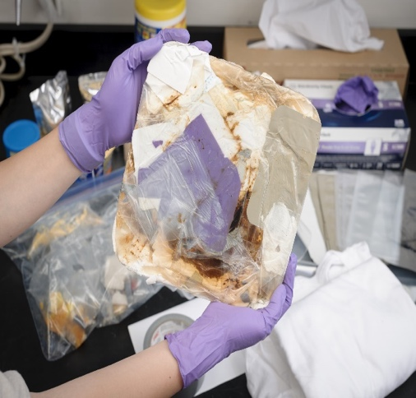
Figure 9 & 10: EMC and EMC Tile

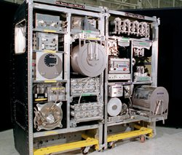
Figure 11: Water Refinery System
The Water Refinery System (WRS) is responsible for urine recovery, water recovery and its contributions to the climate control. The WRS will be split into two racks, one for controlling the urine refinery and the other being the general water refinery that includes the urine after it has gone through its own rack. Each rack will be roughly 4.5 ft by 3 ft. The urine recovery rack will include a multi-filtration bed, distillation assembly, storage tanks, urine processor firmware controller, and a urine processor pump and separator. All these assemblies will take up to 4.5 ft of space by 3 ft. The water recovery portion will intake the filter urine water and refine it even more for it to be potable water through a series of highly precise filtration systems that has been engineered to reach a 98% efficiency rating. The second WRS rack will also use 4.5ft by 3 ft of storage.
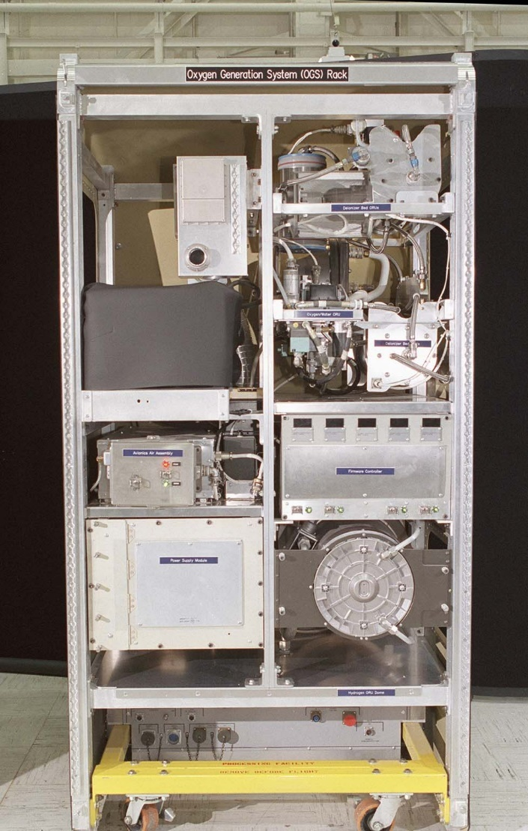
Figure 10: Oxygen Generation System (OGS) Rack

The final rack of the ECLSS will be the Oxygen Generation System (OGS). The OGS rack will compartmentalize the climate control as well as certain pressure regulations. This consists of a deionizer bed, N2 Purge ORU, Firmware control, Electrolysis cell stack and a reserved volume for Sabatier CO2 reduction system. This rack will be roughly 4.5 ft by 3 ft as well.

- Prototype Build
Aidan began physical prototype construction starting with the bone structure. Following the FEA analysis, the updated bone structure was physically created at 1/10th scale. The prototype bone structure was created using #3 rebar at 3/8” thickness. The rebar was cut with a chop saw, and welded together using an AC flux core wire feed welder. The rebar was then grinded down and painted. Figure 11 and 12 below show the current state of the team’s 1/10th scale prototype.

Figure 11: Isometric View of Prototype
Figure 12: Front View of Prototype

- Future Plans and Improvements
    - Sub-System Improvements
      - Whipple Shield Impact Analysis
The Whipple shield is supposed to handle micrometeorite impacts. Simulating the Whipple shield for impact analysis would produce accurate values of buckling forces.
      - Joints and Binding Mechanism
The joints in the bone structure are supposed to be welded. It is assumed for study purposes that the weld material has the same material properties as 6061 T6 Aluminum. However, the real world cannot be simulated in a study. As a result, additional experiments might need to be conducted for the joints.
In addition, the connections between the bone structure, pressure wall and the Whipple shield needs to be resolved which provides a completed full-scale model.
      - Air Lock Mechanism
The next stage of analysis includes figuring out the Air lock mechanism. The air lock needs to pressurize and depressurize the chamber as needed. Additionally, the chamber needs to be big enough to allow the Astronauts to change into the pressure suits. As such the airlock door needs to handle the forces necessary to hold the pressure forces.
  - Prototype Build
Aidan is currently in the process of finding manufacturers to roll sheet metal to wrap around the inside and outside of the bone structure. After that the next step is machining the floor to insert inside the structure, and exterior parts like the legs, the window and the air lock.

